

### USER GUIDE

**WHRSC APPOINTMENT**

### (Updated: 01/14/2019)

# Table of Contents

CREATING THE APPOINTMENT ACTION 2

NAVIGATING THE APPOINTMENT TABS 5

TRANSACTION INFORMATION TAB 6

COMMENTS ANDACTION STATUSCODES/DESCRIPTIONS 8

THE APPOINTMENT INFORMATION TAB 9

DEU APPROVAL OF SELECTIONS FROM A DE ANNOUNCEMENT/CERTIFICATE 14

TRACKING PATHWAYS APPOINTMENTS 15

THE APPROVALS INFORMATION TAB 16

ROUTING THEAPPOINTMENTACTION TO THEDEU 17

PAY INFORMATION TAB 18

FOR ADVANCED RATE OF PAY ACTIONS 18

FOR HIGHEST PREVIOUS RATE ACTIONS 19

ORIENTATION INFORMATION TAB 20

ROUTING OPTIONS 22

FINAL PROCESSING/AUTHORIZATION TAB 25

APPENDIX A: REMINDER EMAILS 26

PATHWAYS ASSIGN AMENTOR EMAIL 26

PATHWAYSESTABLISH AN INDIVIDUAL DEVELOPMENT PLAN(IDP)ANDSTRUCTURED TRAINING EMAIL 26

PATHWAYS PROGRAM ENDING EMAIL- PMF 27

PATHWAYS PROGRAM ENDING EMAIL – RECENT GRADUATES 27

REEMPLOYED ANNUITANT EMAIL 28

OGE - 278 FILER EMAIL - CLIENT FEEDBACK 28

ENTRANCE ON DUTY (EOD)DATE DEADLINEEMAIL 29

TENTATIVE JOB OFFER EMAIL 29

OFFICIAL JOB OFFER EMAIL 30

RETRIEVE APPOINTMENT SF-50 FOR RECRUITMENTCASE FILE 30

SEND APPOINTMENT ACTION TO FINAL AUTHORIZER 31

APPENDIX B: APPOINTMENT WORKFLOW 32

# Creating the Appointment Action

The **Appointment** workflow is used to track the processing of employee appointments. It can be initiated as part of the Recruitment workflow, Unassigned Staffing Process or as a Stand- alone Appointment action. The gaining WHRSC Branch or WHRSC staff member is responsible for creating the action.

### From the Recruitment workflow:

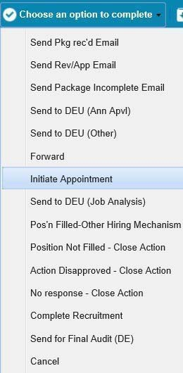The Appointment workflow can be initiated as a “sub process” to the Recruitment workflow from within the Recruitment action routing options. From within the Recruitment form, the HR Specialist initiates an Appointment action by choosing Initiate Appointment from the routing menu at the top of the page.

The Appointment action will be initiated and sent to your worklist.

### From the Unassigned Staffing Processes BizCove:

The Appointment workflow can be initiated from the Unassigned Staffing Processes BizCove on the Work Area Page. Job requisitions are entered and approved in the Capital HR system. After a Capital HR Job Requisition is approved, an action is automatically generated in EWITS

2.0 and can be found in the **Unassigned Staffing Processes** BizCove. Because the system does not know whether the incoming action is a Recruitment or an Appointment, it is held in the unassigned staffing area until a WHRSC staff member retrieves it and assigns it as either a Recruitment or an Appointment.

Assigning these actions and beginning work on them in a timely manner is critical. For this reason, a series of reminder emails are sent when an action has not been assigned to an HR Specialist:

**On the 3rd day** – email to all Team Leaders in the branch **On the 5th day** – email to Branch Chief

**On the 7th day** – email to Deputy Director that is assigned to the branch

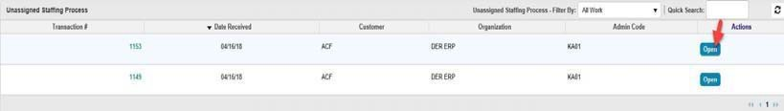To assign the action, the WHRSC staff member clicks on the “Open” button.

When the WHRSC staff member opens the action, the Determine Staffing Process form displays the information that was transmitted from Capital HR.

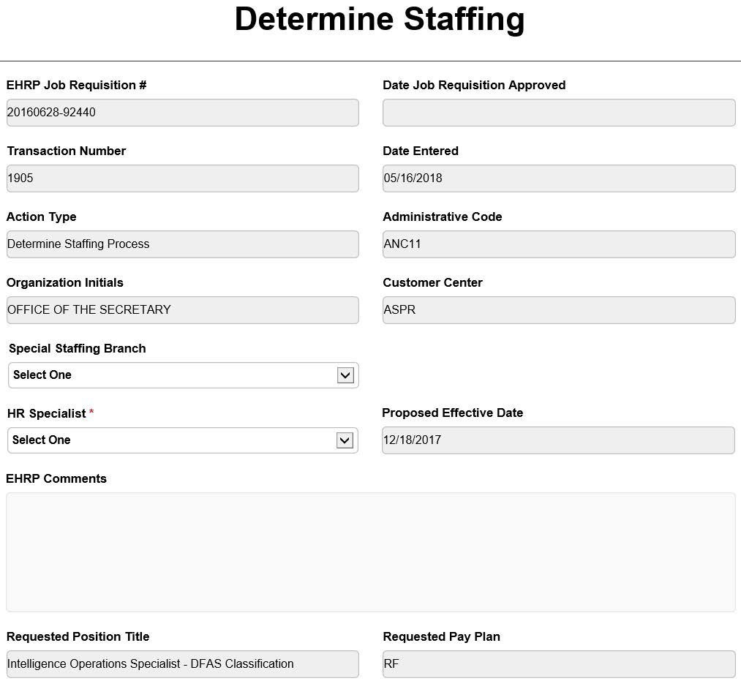

The WHRSC staff member reviews this information and determines whether the action is a Recruitment or an Appointment. This step is necessary because WHRSC staff member may enter Capital HR Job Requisitions for Recruitments but may also enter them for Appointments where recruitment is not necessary (e.g., Shared Certificate selections, Committee Members, Special Experts, certain non- competitive appointments, etc.). Whether the Capital HR Job Requisition is used in this manner will vary between staff members.

All of the fields on the Determine Staffing Process page contain information that was entered by the WHRSC staff member and cannot be edited. These fields can be edited after an Appointment or Recruitment action is created. Blank fields indicate that the WHRSC staff member did not enter the information into Capital HR.

Any comments the WHRSC staff member entered into the Capital HR Job Requisition are listed in the Cap HR Comments field.

### Steps for assigning a Determine Staffing Process action to an HR Specialist:

The WHRSC staff member indicates whether the Special Staffing Branch (SSB) will handle the action or not.

The WHRSC staff member assigns the action to the appropriate HR Specialist by selecting their name from the HR Specialist drop.

If the action is an Appointment, the WHRSC staff member clicks the "Appointment" button at the bottom of the screen.

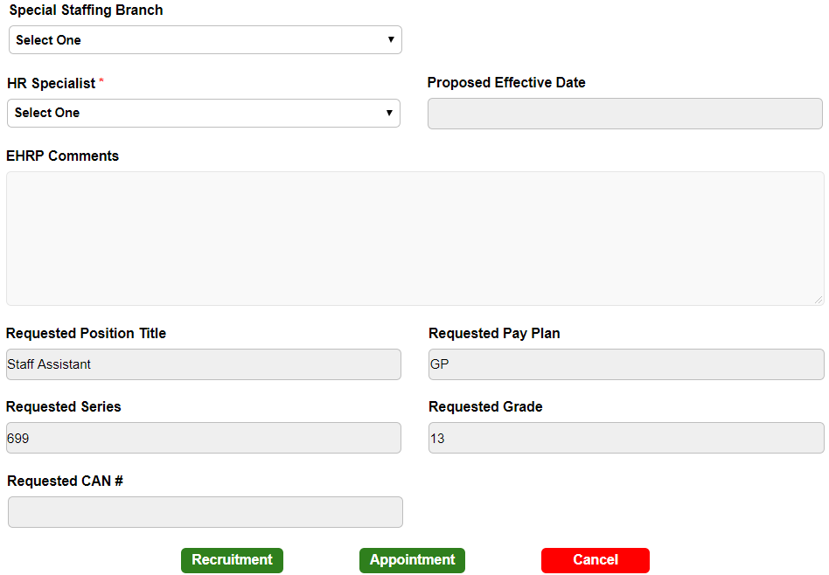

### Navigating The Appointment Tabs

Once appointment is initiated in EWITS 2.0, WHRSC HR Specialist can access the action in their worklist by clicking on the action. After clicking on the action; a form with the following tabs will appear:

* Transaction Information
* Appointment Information
* Approvals Information
* Pay Information
* Orientation Information
* Final Processing/Authorization

# Transaction Information Tab

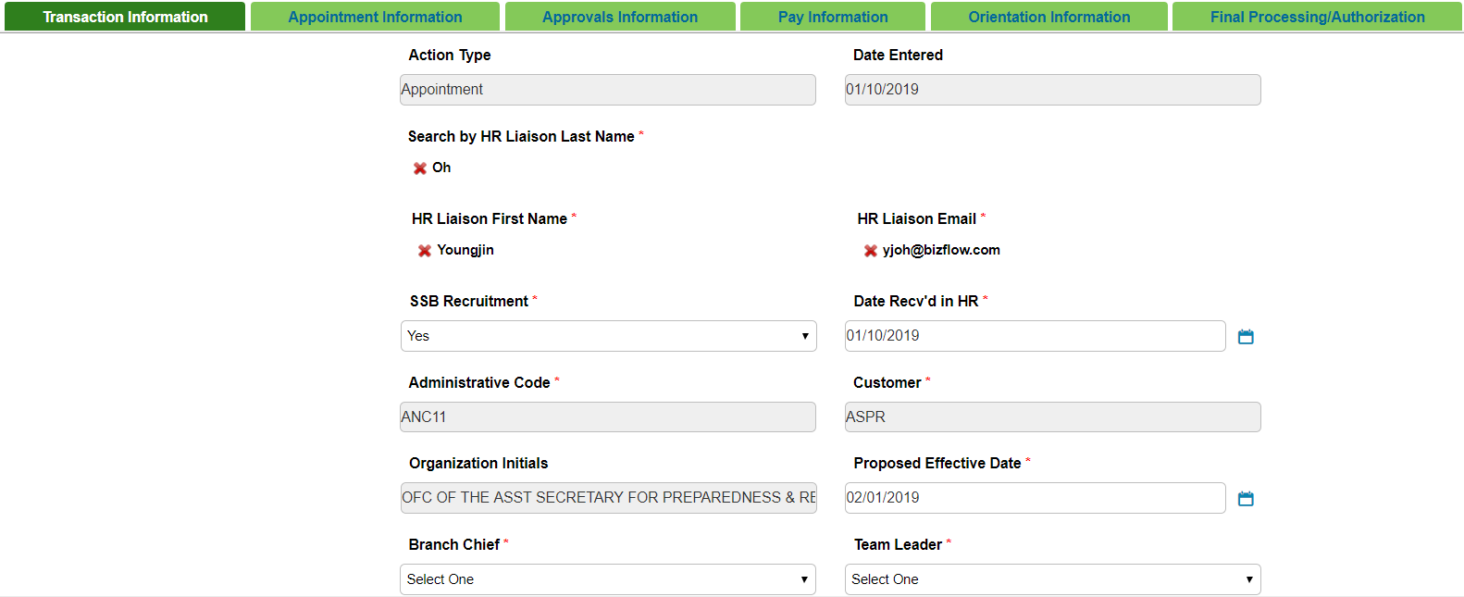

**Action Type:** Auto-populated from CAP HR. **Date Entered:** Auto-populated from CAP HR.

**HR Liaison Last Name, First Name and Email address:** The HR Liaison's First Name and Email Address will be auto-populated by typing/locating the last name for that HR Liaison.

**SSB Recruitment:** Select “Yes” if this is a Special Staffing Branch recruitment. Otherwise, select “No.”

**Date Rec’d in HR:** Enter the date that the initial Appointment package or request was received. For Recruitment-initiated Appointments, this field will be auto-populated with the date the action was initiated from the Recruitment action. You can change this date if you initiate the appointment action after the request or appointment package was received.

### Administrative Code, Customer, Organization Initials:

Auto-populated from CAP HR.

**Proposed Effective Date:** Enter the Proposed Effective Date of the appointment. Update this date if the Proposed Effective Date changes during the appointment process.

**Is the package complete:** Indicate whether the initial appointment package submitted by the WHRSC staff member / Program is complete (you have all required documents/ information needed to process the appointment). If the initial appointment package is not complete, select ‘No.’ Do NOT change this field when the WHRSC staff member /Program area submits a complete package. Once you select, ‘No’, leave this field as ‘No.’

**Date Missing Docs Email Sent:** Will be auto-populated once user selects "Send Package Incomplete Email".

**List of Missing Docs/Info:** Enter any relevant comments.

**Date Complete Package Received:** Indicate the date you received all of the required documentation to process the Appointment action.

**Priority:** Select the appropriate priority.

**Action Status Code:** Select the appropriate action status code. **Action Status:** Select the appropriate action status.

**Action Status Description:** Select the appropriate action status description.

## Comments and Action Status Codes/Descriptions

Comments, Action Status Code, Action Status, and the Action Status Description fields are visible to HR staff and WHRSC staff members on a majority of reports. It is important that these fields are current and accurate. Entries in the Comments section should include a timeline of the action’s progression. They should be listed in reverse chronological order with the most recent entry at the top of the comments field, and they should be updated at least weekly.

### Best Practices for Comments:

**Be Brief** — The Comments field allows 5000 characters, which includes spaces. List only what is necessary to avoid causing the action’s entry in the reports to be excessively lengthy.

**Be diplomatic**—Your comments should not include sensitive information about employees. Be mindful that our WHRSC staff members might be able to view these comments through future reports. Be careful not to give the appearance of assigning “blame” if an action is taking longer than expected.

**Be careful** — Do not add any information related to name requests or other information that may give the appearance of pre- selection.

**Be timely** – Your comments should reflect the most recent status of the action and always check your spelling and grammar.

# The Appointment Information Tab

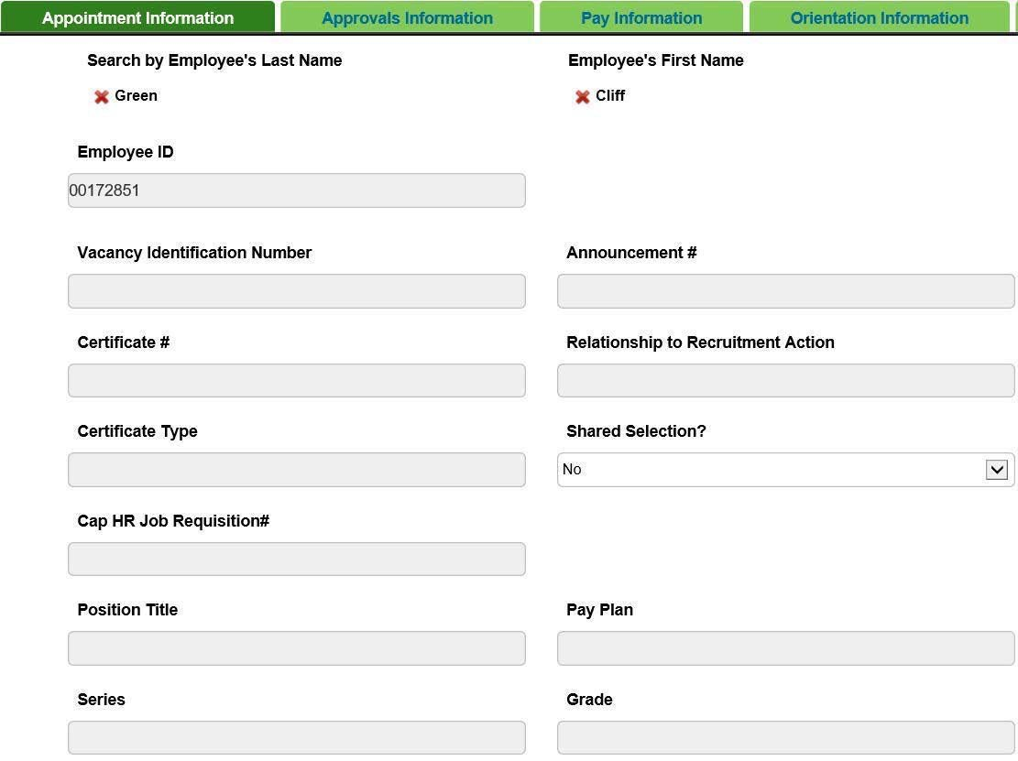

**Employee's First Name, Last Name, Employee ID:** The Employees First Name and Employee ID will be auto- populated by typing/locating the Last Name for that employee.

## Induction Service

For employees who are new to HHS and who do not have an employee ID, the induction service will be used to generate the HHS ID and retrieve the related Security Information that will be saved to the WHRSC database (not visible on the Appointment form). Click the ‘Click to link record with PSC Security’ to launch the Induction form.

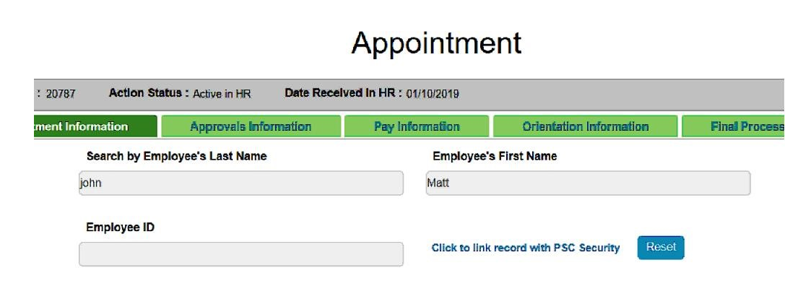

## Security Clearance Information

**Last Name:** This field is auto-populated from the Appointment form

**First Name:** This field is auto-populated from the Appointment form

**Identification Type:** Select the appropriate Identification Type: VISA Number, Social Security Number (SSN), Alien Registration Number, Foreign ID

**Date of Birth:** Enter the Date of Birth of the employee

**OPDIV:** Select the OPDIV of the employee to be inducted

**Affiliation:** Select the appropriate Affiliation code

***Appointment Information continued . . .***

**Vacancy Identification Number:** This field is auto-populated from the USA staffing system.

**Announcement Number:** This field is auto-populated from the USA staffing system.

**Certificate Number:** This field is auto-populated from the USA staffing system.

**Relationship to Recruitment Action:** This field is auto-populated from the USA staffing system.

**Certificate Type:** This field is auto-populated from the USA staffing system.

**Cap HR Job Requisition Number:** This field is auto-populated from CAP HR.

**Shared Selection:** Indicate if this is a Shared Certificate or Shared Recruitment else choose ‘No’ if either.

**External Certificate Number:** This field will be visible if the Shared Selection is ‘Shared Certificate’ or ‘Shared Recruitment’ and if the Certificate # is blank

**Certificate Details:** This field is auto-populated from the USA Staffing system and is displayed along with the External Certificate Number

**Position Title, Pay Plan, Series & Grade:** This field is auto-populated from the USA staffing system.

**Full Performance Level (FPL):** This field is auto-populated from the USA staffing system. **Step:** Select the appropriate step.

**Pay Tier:** Select the pay tier. **Pay Band:** Select the pay band. **Job Code:** Enter the job code.

**Position Number:** Enter the position number.

**Communication Point**

After the Transaction Tab and the appointee’s basic information (first/last name, email address, position information) has been completed, the HRS selects “Send Package Received Email” from the “Choose an option to complete” routing menu located at the top of the screen to send an email notice to the HR Liaison advising them that the Appointment action has been received in HR.

**Duty Station & Location:** This field is auto-populated from the USA staffing system. **Duty Station Code:** This field is auto-populated from the USA staffing system.

**Search by Reports to (Supervisor) First Name, Last Name, Email Address:** The Supervisors First Name and Email Address will be auto-populated by typing/locating the Last Name for that supervisor.

**CAN:** Enter the Common Accounting Number.

**Supervisory Status:** This field is auto-populated from the USA staffing system. **HIRED System Used:** Select "Yes" or "No".

**HIRED #:** Enter the HIRED Number if applicable.

**Legislative Initiative Supported:** Indicate whether the position will be supporting one of the following: The American Recovery and Reinvestment Act (ARRA), Roadmap, Stem Cell, or Other research. If the position will not be supporting a Legislative Initiative, select N/A.

**Date Cert Sent to Selecting Official:** This field is auto-populated from the USA staffing system.

**Date of Hiring Decision:** This field is auto-populated from the USA staffing system.

**Date Hiring Decision Received in HR:** This field is auto-populated from the USA staffing system.

**Date of Tentative Job Offer:** This field is auto-populated from the USA staffing system.

**Additional Approval Required:** Select "Yes" or "No".

**Additional Approval Comment:** Enter any relevant comment.

**Date of Official Job Offer:** This field is auto-populated from the USA staffing system.

**OF-306 Assigned in Onboarding Manager:** This field is auto-populated from the USA staffing system.

**Clearance Level Required for Position:** This field is auto-populated from the USA staffing system.

**Date Security Notification Received:** This field is auto-populated from the BITS system for the employee

**Security Review Disposition:** This field is auto-populated from the BITS system for the employee

**Type of Selection:** This field is auto-populated from the USA staffing system.

**Appointment Type:** Select the appropriate type. Your selection here will dictate what values are populated in the Nature of Action code field.

**OGE - 278 Filer:** Select "Yes" or "No".

**Nature of Action Code:** Select the appropriate code. **OGE - 450 Filer:** Select "Yes" or "No".

**Priority Placement:** Indicate whether this will be a priority placement. Note: CTAP- Career Transition Assistant Plan, ICTAP- Interagency Career Transition Assistant Plan, N/A - Appointee is not a priority placement appointee.

**Hiring Flexibility Type:** Select the appropriate type. **Basic Pay:** Enter the appointee's Basic Pay.

**Adjusted Basic Pay:** Enter the appointee's Adjusted Basic Pay. **Professional Designation:** Select the appropriate designation.

**Medical Specialty:** Select the appointee's medical specialty, if applicable. **Board Certification:** Enter the appointee's board certification, if applicable. **Eligible for Benefits:** Select "Yes" or "No".

**Veterans Preference:** Select the appointee's appropriate veteran’s preference.

**Reemployed Annuitant:** Indicate whether the appointee is a reemployed annuitant or not. If the appointee is a reemployed annuitant, indicate if they have been granted a waiver of salary offset or not.

**EOD (report to duty):** This field is auto-populated from the USA staffing system. **NTE Date:** Select from calendar.

**Date Educational Docs Rec'd:** Select from calendar.

**How did appointee hear about position:** Select all that apply.

## DEU Approval of Selections from a DE Announcement/Certificate

The Branch HR Specialist (Branch HRS) must route the Appointment action for selection approval for DE selections.

**Note:** Selection approval by the Delegated Examining Unit (DEU) is only needed for the Official Job Offer. The Branch HRS should make the Tentative Job Offer before sending the action to the DEU.

Before sending the action to the DEU for approval, the Branch HRS must complete all of the information on the Transaction Information Tab (including ‘Date Complete Package Received’), and the following fields on the Appointment Information tab:

* Appointee's First and Last Name
* Appointee’s Email Address
* Related Recruitment Announcement #
* Certificate #
* Relationship to Recruitment Action
* Certificate Type
* Position Title
* Pay Plan
* Series
* Grade
* Date of Hiring Decision
* Date Hiring Decision Received in HR
* Hiring Flexibility Used (If “Yes” and the Hiring Flexibility Type is mandatory)
* Priority Placement
* Veterans Preference

The Branch HRS will select the DEU Selection Approver (the individual who will approve or disapprove of the selection) from the ‘DEU Selection Approver’ drop-down menu.

## Tracking Pathways

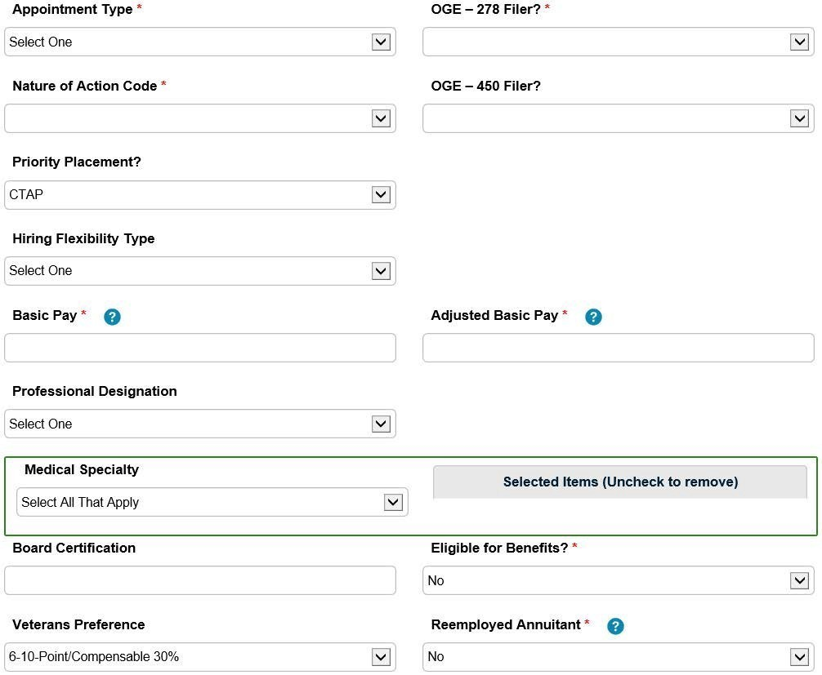

When appointing an individual into a Pathways position (i.e., WHRSC Intern, Recent Graduate, or Presidential Management Fellow) there are specific fields that need to be completed. This information is used to help WHRSC track Pathways appointments and send various reminder emails to ensure compliance with regulations. For more information on Pathways reminder emails please see the Reminder Emails section of this guide.

**Pathways Agreement Completed:** Indicate that the Pathways Agreement was completed.

**For Pathways Interns (Temporary and Indefinite),** indicate if the new hire requires a work permit. If a work permit is required, indicate the date it was received.

**Expected Date of Program Completion:** Enter the appointee’s expected program completion date.

**For Recent Graduates and Presidential Management Fellows,** the ‘Pathways Agreement Completed?’ and ‘Expected Date of Program Completion’ fields need to be completed.

**For WHRSC Interns (Temporary and Indefinite),** the ‘Pathways Agreement Completed?’ field needs to be completed.

# The Approvals Information Tab

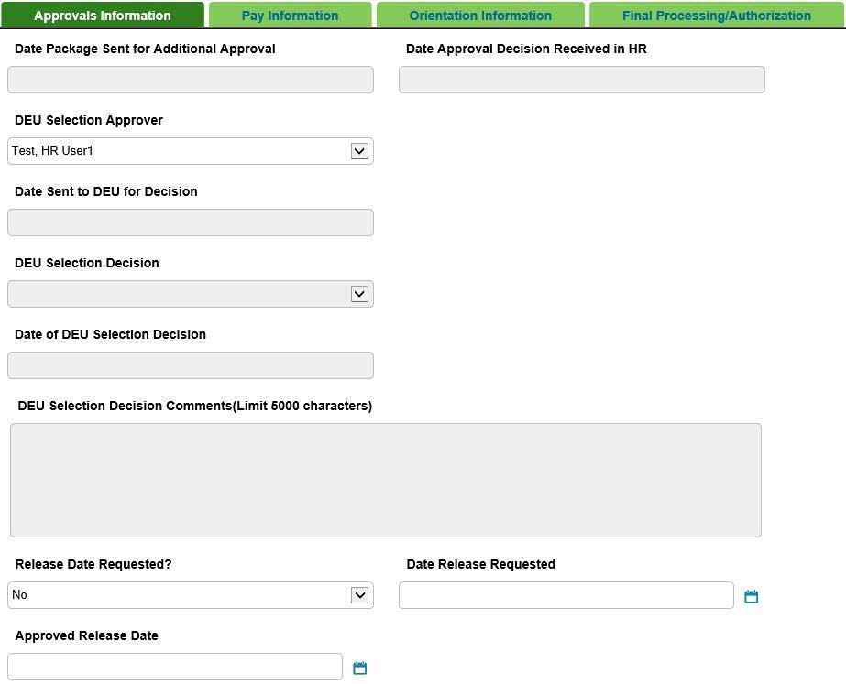

**Date Package Sent for Additional Approval:** Enter the date the package was sent for Additional Approval. This field is enabled when ‘Additional Approval Required?’ is selected as ‘Yes’ on the Appointment Information tab.

**Date Approval Decision Received in HR:** Enter the date the approval decision was received in HR. This field is enabled when ‘Additional Approval Required?’ is selected as ‘Yes’ on the Appointment Information tab.

**DEU Selection Approver:** Select the individual in the DEU who will approve of the DE selection. This individual is typically the same person who issued the certificates (i.e., DE HR Specialist).

**Date Sent to DEU for Decision:** This field is auto-populated by when the action is sent to DEU for decision.

**DEU Selection Decision:** Select the appropriate option (DEU only).

**Date of DEU Selection Decision:** Enter the date of DEU Selection Decision (DEU only).

**DEU Selection Decision Comments:** Enter any relevant comments (DEU only).

**Release Date Requested:** Select "Yes" or "No". **Date Release Requested:** Select from calendar. **Approved Release Date:** Select from calendar.

## Routing the Appointment Action to the DEU

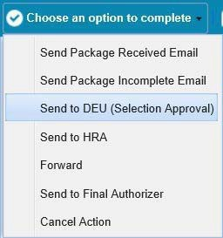

The Branch HRS selects ‘Send to DEU (Selection Approval’ from the routing menu to send the action to the WHRSC DEU:

An email is sent to the Branch HRS and the DEU Selection Approver. This email notifies both parties that the WHRSC DEU has received a request to review a selection for approval.

The DEU Selection Approver will complete the following fields. Only members of the WHRSC DEU can complete the following fields: DEU Selection Decision, Date of DEU Selection Decision, Additional DEU Selection Info Needed and DEU Selection Decision Comments.

### WHRSC DEU Selection Review/Approval

**After the DE Selection Approver has reviewed the selection, he or she will either:**

**Approve the Selection**

In this case, the Branch HRS will receive an email stating that the selection has been approved by the DEU and the Branch is authorized to extend an official job offer. Additionally, the program will return the action to the Branch HRS with the ‘Date of DEU Selection Decision’ field completed.

### Disapprove the selection

In this case, the Branch HRS will receive an email stating that the selection has not been approved by the DEU. As a result, the program will return the action back to the Branch HRS.

### Mark the action as "More Information Needed"

In this case, the Branch HRS will receive an email stating that the action is being returned to them because additional information/documentation is needed. As a result, the program will return the action back to the Branch HRS. Once the Branch HRS receives the approved Appointment action back, he or she can make the Official Job Offer and continue with the Appointment process.

# Pay Information Tab:

**Note:** This tab only needs to be completed if you are using an Advanced Rate of Pay or Highest Previous Rate appointment.

**Pay Type:** Indicate whether or not the salary is based on the individual’s Highest Previous Rate (HPR) or if the salary is being set as an Advanced appointment. Your selection of the Pay Type will drive the information displayed on this tab.

## For Advanced Rate of Pay actions

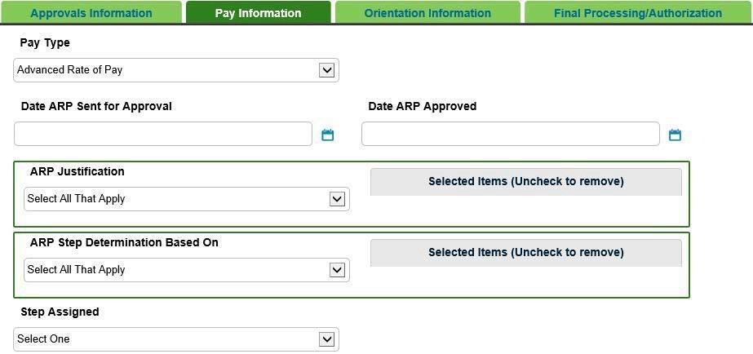

**Date ARP Sent for Approval:** Select from calendar. **Date ARP Approved:** Select from calendar.

**ARP Justification:** Select all that apply.

**ARP Step Determination Based on:** Select the basis for the step determination. Select All that Apply.

**Step Assigned:** Select the approved step for the ARP if applicable.

## For Highest Previous Rate actions

**Date HPR Authorized by customer:** Select from calendar.

**Maximum Payable Rate:** Enter the highest dollar amount the customer is allowed to offer the appointee under the Maximum Payable Rate.

**Step Assigned:** Select the approved step under the use of the Highest Previous Rate.

# Orientation Information Tab

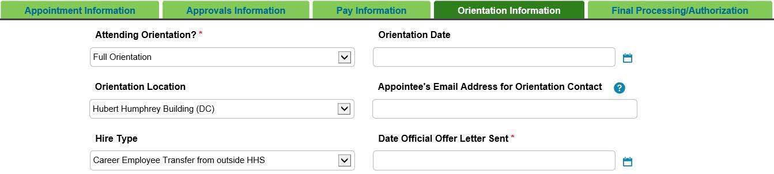

**Attending Orientation:** Indicate if the appointee will be attending the "Full Orientation", "Not Attending" or "Presentation Only".

**Orientation Date:** Select from calendar.

**Orientation Location:** Select the location of the orientation session the appointee will be attending.

**Appointee’s Email Address for Orientation Contact:** Enter the appointee’s personal email address that will be used to contact the appointee regarding orientation. I.E. to inform them of the room location or any cancellation messages. Note: Do not enter a Government Email Address.

**Hire Type:** Select the Hire type. See Hire type explanations below.

**Career Employee Reassignment within HHS:** Select this option for career employees who are being reassigned (or moved) within HHS.

**Career Employee Transfer from outside HHS:** Select this option for career employees who are being transferred from another agency outside of HHS.

**New Hire Greater than 1 Year Appt:** Select this option for new hires or new career conditional/career employees, reemployed annuitants, or rehires to the federal government who are being placed on an appointment greater than one year.

**New Hire Less than 1 Year Appt:** Select this option for non-summer new hires, reemployed annuitants, rehires to the federal government who are being placed on an appointment less than one year.

**Summer Only:** Select this option for individuals who will be placed on an appointment during the typical summer months only.

**Date Official Offer Letter Sent:** Select from calendar.

# Routing Options

### At any time during this process, the HR Specialist or Assistant has the option to:

Send an email to the HR Liaison to advise them that the Appointment package has been received by selecting “Send Package Received Email” from the routing menu.

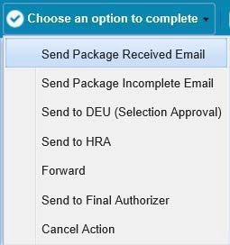

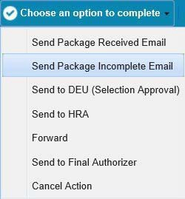Send an email to the HR Liaison to advise them that the Appointment package is incomplete (missing either documentation or information) by selecting “Send Package Incomplete Email” from the routing menu.

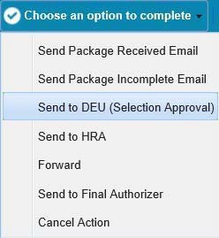Send to DEU for Selection Approval

Send the action to their HR Assistant for completion of the form by selecting “Send to HRA” from the menu. The action will be sent to the HR Assistant who is assigned on the Transaction Information Tab.

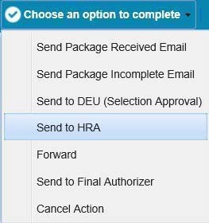

Reassign the action to a new HR Specialist

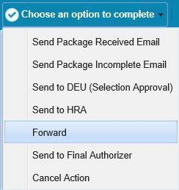

After all of the tabs have been completed, the HR Specialist (or HR Assistant) selects “Send to Final Authorizer” to send the action to the final authorizer for final processing.

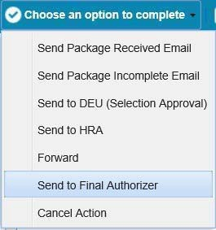

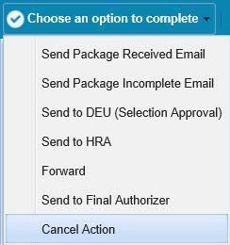Cancel the current action

# Final Processing/Authorization Tab

The Final Authorizer reviews the information on all tabs and completes the Effective Date on the Final Processing/Authorization tab.

**Effective Date:** The date on which the personnel action takes place and on which the employee's official assignment begins. Manually entered by the Final Authorizer.

The Final Authorizer then selects “Action Complete” from the available routing options.

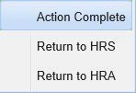

# Appendix A: Reminder Emails

Throughout the appointment process, the program sends escalation and reminder emails to HR staff as well as to our WHRSC staff members based on certain dates and data that is entered on the related forms. These emails are intended to keep the processes moving in a timely fashion, to help ensure that we meet our mutual hiring reform goals, and to provide HR/WHRSC staff members with helpful reminders.

## Pathways Assign a Mentor Email

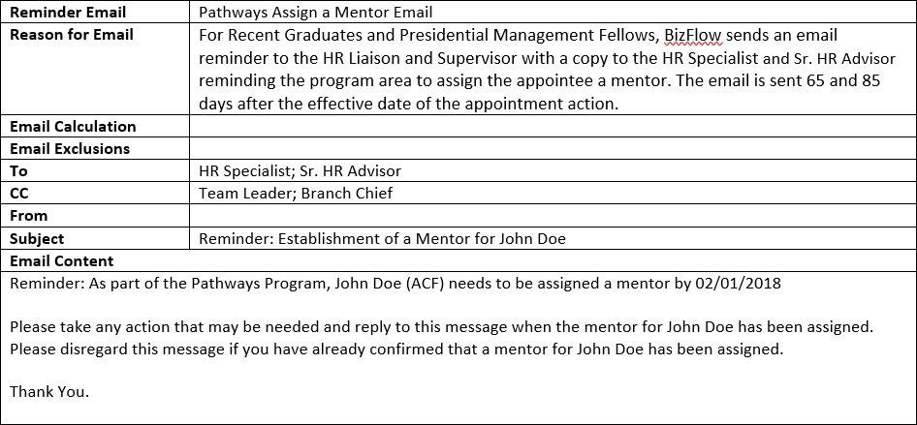

**Pathways Establish an Individual Development Plan (IDP) and Structured Training Email**

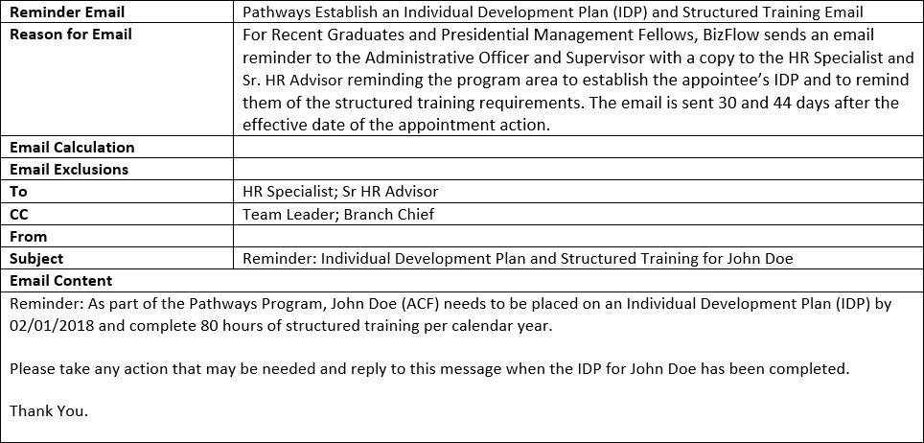

**Pathways Program Ending Email - PMF**

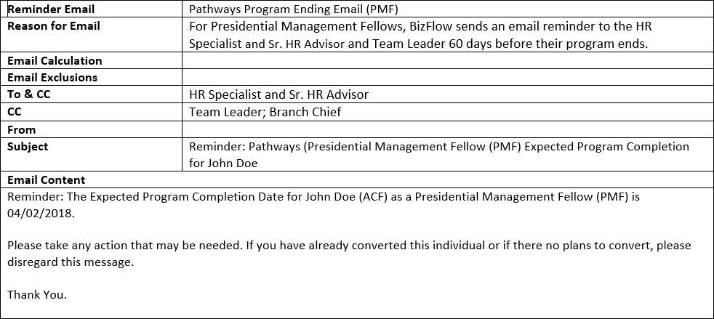

**Pathways Program Ending Email - Recent Graduates**

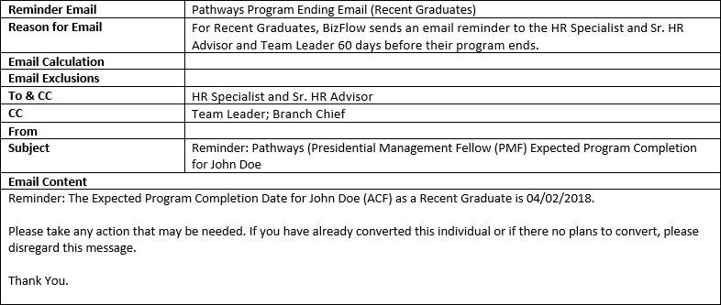

**Reemployed Annuitant Email**

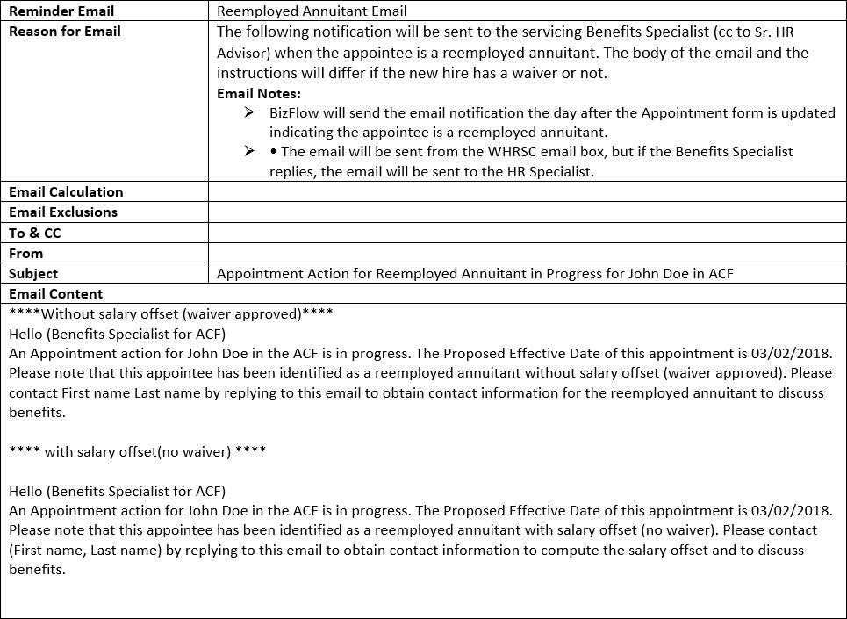

**OGE - 278 Filer Email - Client Feedback**

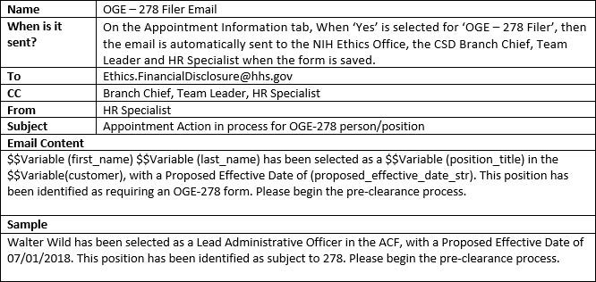

**Entrance on Duty (EOD) Date Deadline Email**

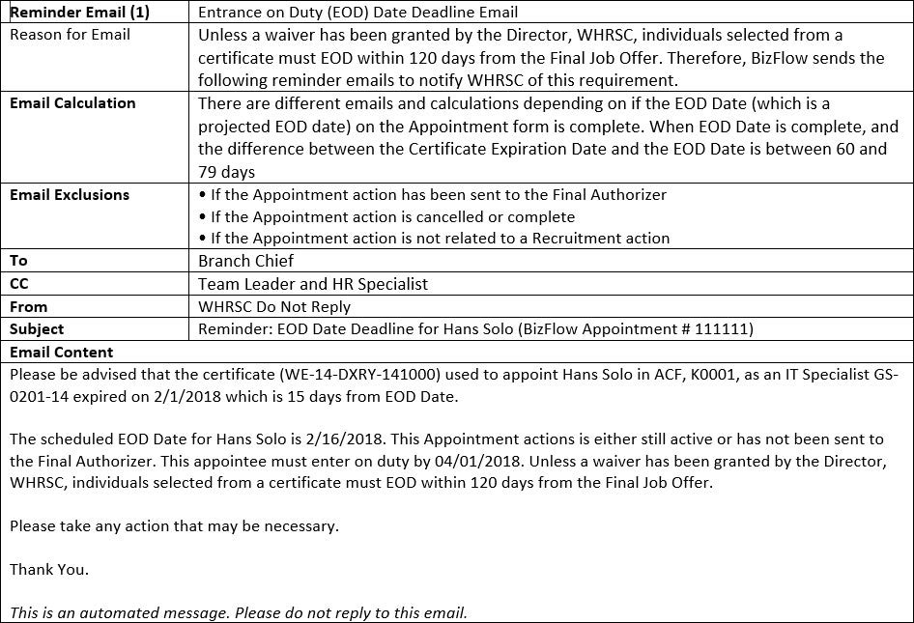

**Tentative Job Offer Email**

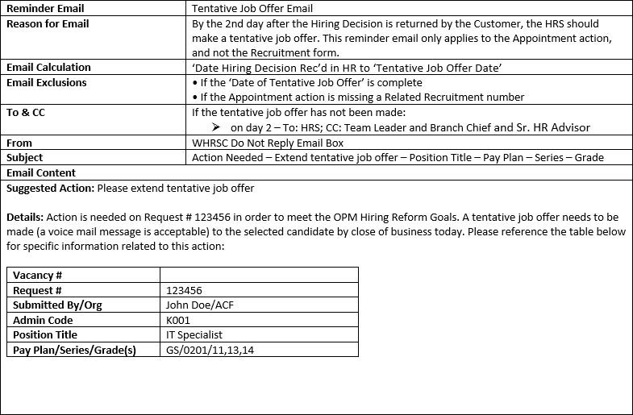

## Official Job Offer Email

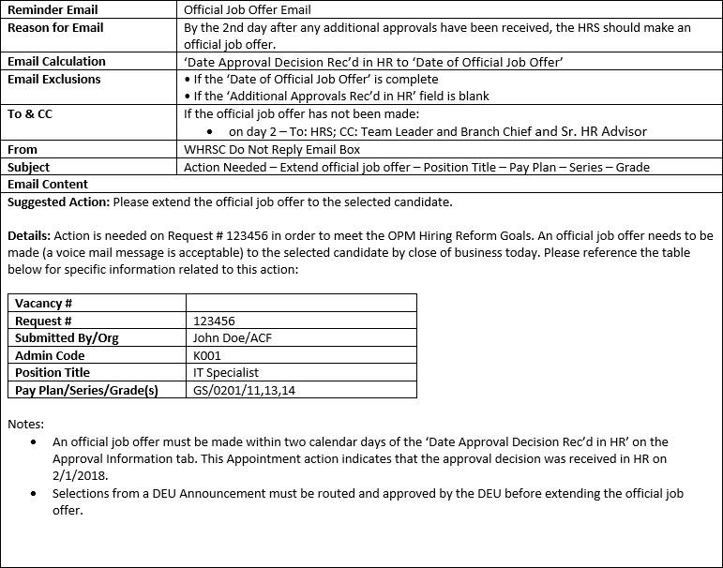

**Retrieve Appointment SF-50 for Recruitment Case File**

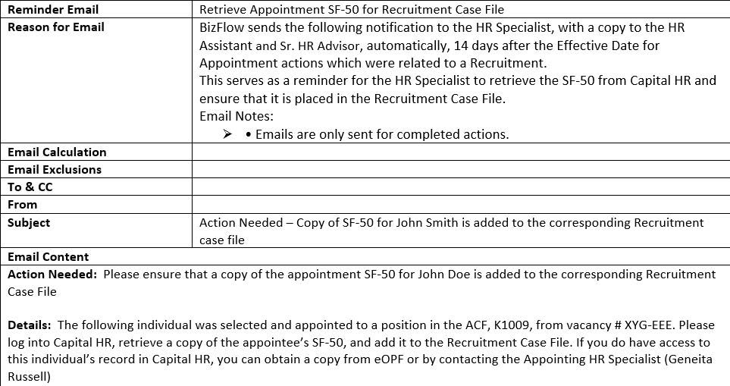

## Send Appointment Action to Final Authorizer

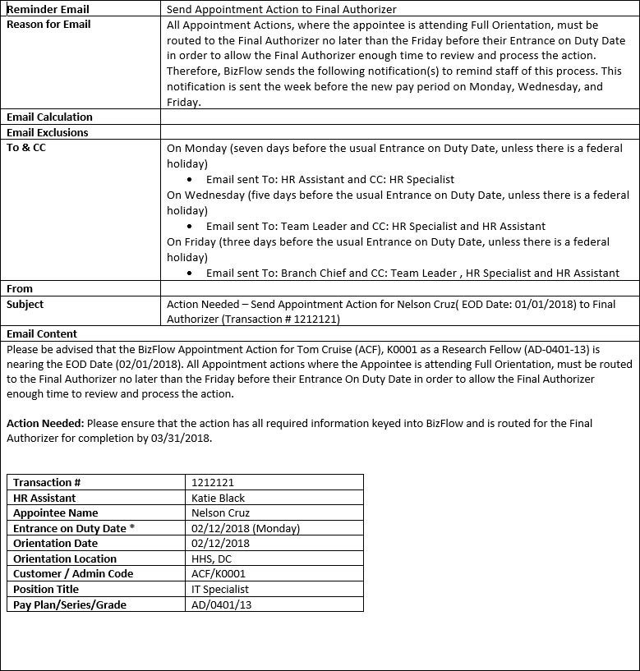

# Appendix B: Appointment Workflow

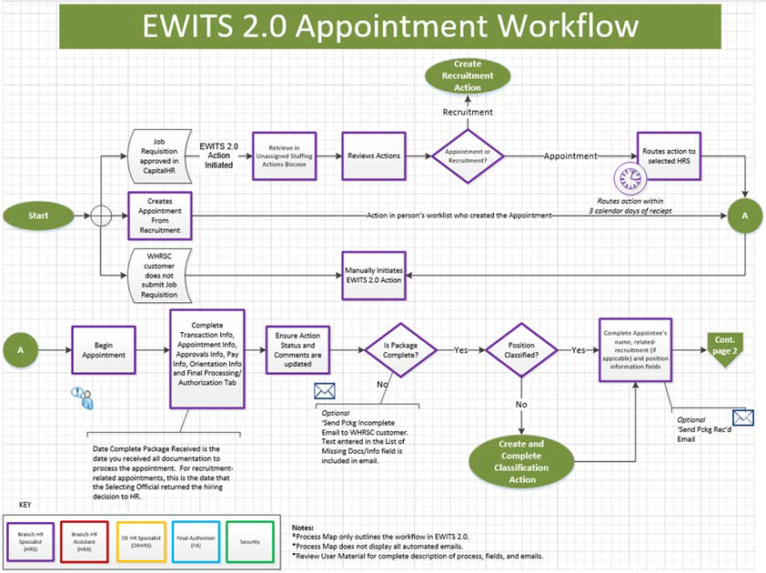

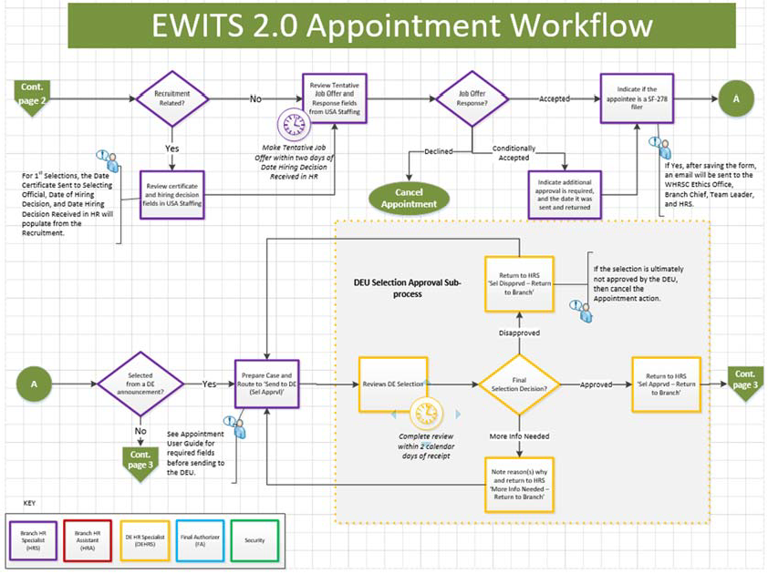

**Appendix B: Appointment Workflow**

